STUDENT PASS/FAIL
PREDICTOR
STUDENT PASS/FAIL
PREDICTOR
(PROJECT REPORT)

BY SHALINI PAL
25BHI10018
FUNDAMENTAL IN AI ML

INTRODUCTION
The student pass/fail predictor is a simple rule-based system designed to determine whether a student is likely to pass or fail based on key academic indicators such as study hours and attendance percentage.
In today’s digital learning environment, early prediction of student performance can help identify areas of improvement and encourage better study habits. This project demonstrates a basic concept of decision-making similar to Artificial Intelligence using conditional logic.

PROBLEM STATEMENT
Many students struggle to understand how their study habits and attendance affect their academic performance. There is a need for a simple system that can:
- Analyze basic student data
- Provide quick performance prediction
- Help students make better academic decisions

FUNCTIONAL REQUIREMENTS
The system should:
- Accept user input (study hours and attendance)
- Process the input using predefined logic
- Display result (PASS/FAIL)
- Allow repeated predictions
- Handle invalid inputs (optional improvement)

NON-FUNCTIONAL REQUIREMENTS
1. Usability: Simple and user-friendly interface
2. Performance: Instant result generation
3. Reliability: Accurate based on defined rules
4. Scalability: Can be extended to real AI models
5. Maintainability: Easy to modify logic

SYSTEM ARCHITECTURE

The system follows a simple structure:
User Input → Processing Function → Output Result
Components:
- Input Module
- Processing Module (Decision Logic)
- Output Module

DESIGN DIAGRAMS
ALGORITHM
1. Start
2. Define Function
Create a function predict_pass_fail(hours, attendance)
3. Apply Decision Logic
- If hours ≥ 3 and attendance ≥ 75
→ Return "PASS"
- Else
→ Return "FAIL"
4. Begin Loop
- Start an infinite loop to allow repeated predictions
5. Display Title
- Print “Student Predictor”
6. Take User Input
- Input study hours
- Input attendance percentage
7. Call Function
- Pass inputs to predict_pass_fail(hours, attendance)
8. Display Result
PSEUDOCODE
- Start
- Loop
Input study_hours
Input attendance
If study_hours >= 3 AND attendance >= 75 THEN
Print “PASS”
Else
Print “FAIL”
ENDIF

Ask user to continue
If answer is not “yes”
EXIT LOOP
END LOOP
END

FLOWCHART
START

ENTER STUDY HOURS AND ATTENDANCE

IS HOURS >= 3 AND ATTENDANCE >= 75?
NO
YES

PRINT FAIL
PRINT PASS

END

DESIGN DECISIONS
- Used rule – based logic instead of machine learning for simplicity
- Chose python for easy implememtation
- Selected 3 hours & 75% attendance as threshold values
- Used loop for continuous user interaction

IMPLEMENTATION DETAILS
- Language: Python
- Key Function: predict_pass_fail()
- Loop used for repeated execution
- Conditional statements for decision making

TESTING APPROACH

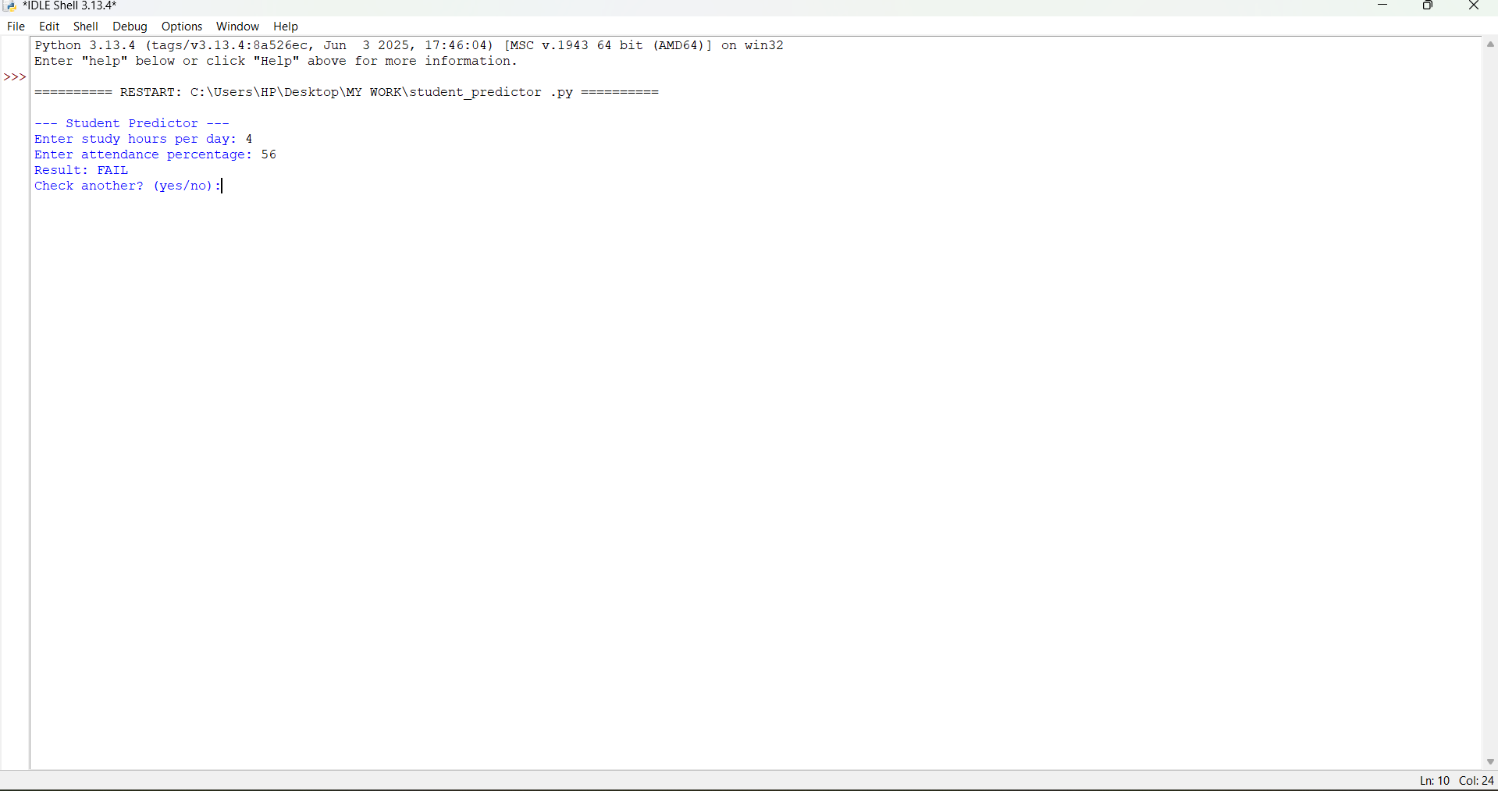

LEARNINGS AND KEY TAKEAWAYS
- Understanding of conditional logic
- Basics of decision – making systems
- Importance of user input validation
- Structure of real – world software projects
- Introduction to AI Concepts

CHALLENGES FACED

  - Defining accurate rules – Choosing the correct thresholds for study hours and attendance to make accurate predictions can be tricky
  - Limited decision – making – Since it’s rule- based system, it cannot adapt or learn from new data
  - Handling unexpected inputs – Users might enter invalid data, which can cause errors
  - Scalability – This simple system works for small input sets, but cannot handle complex scenarios with multiple parameters
  - No probabilistic reasoning – the system cannot handle uncertainity or borderline cases; it’s purely deterministic
  - Lack of data- driven accuracy – Predictions are based on fixed rules, not on real historical student data, so accuracy may be limited

FUTURE ENHANCEMENTS
    - Convert to machine learning model
    - Add more parameters (marks, assignments, behavior)
    - Develop GUI using Tkinter
    - Create web – based version
    - Store and analyze historical student data

CONCLUSION
THE PROJECT SUCCESSFULLY DEMONSTRATES HOW SIMPLE LOGIC CAN BE USED TO PREDICT STUDENT OUTCOMES. IT SERVES AS A FOUNDATIONAL STEP TOWARD BUILDING MORE ADVANCED AI – BASED EDUCATIONAL TOOLS.

